**BUG TRACKING SYSTEM**

Bug tracking system is the web application project to manage the errors or bugs occur during software development phase. Tester can add the bug and the developer can view those bugs. Developer can also search the solution for early occurred bugs in the bug report.

Modules:

1. **Employee Module**:

Employee can either be a developer or a tester. Tester adds the bug to the bug report. Developer views the bug and finds the solution for the same.

1. **Manager Module**:

Manager handles the projects and employees required for the project.

1. **Administrator module**:

Administrator manages the entire system.

Database design:

**Admin**



**Employee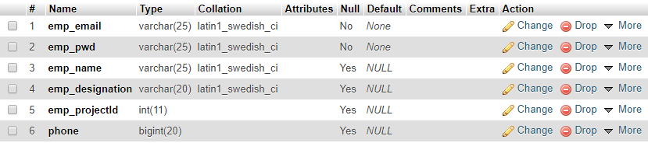Bug**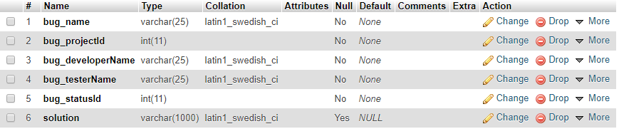

**Project**



**Status**

